Algebra 1: Unit 8, Lesson 6

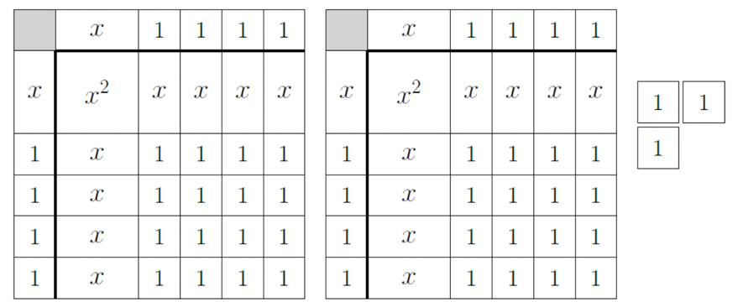
- A diagram of algebra tiles is shown below.

A student wrote the expression $2{(x+4)}^{2}-3$ to represent the algebra tile diagram above, but made a mistake. Fix the students’ error.
$$2{(x+4)}^{2}+3$$

- The table shows an expression modeled with algebra tile product mats.
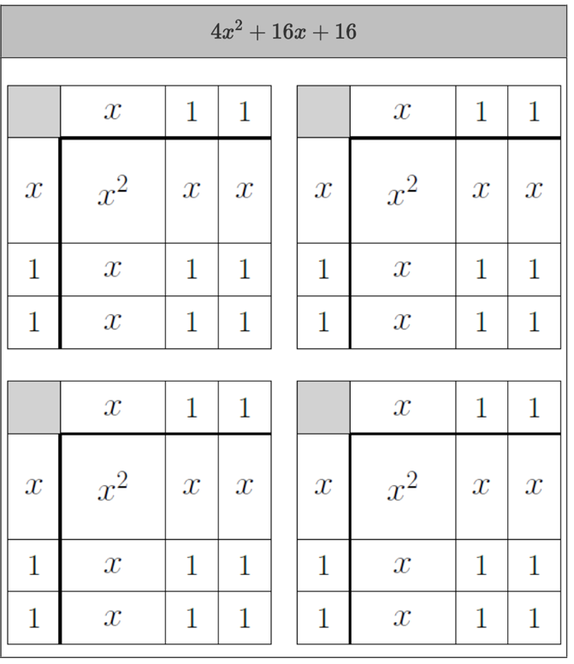

For the algebra tile representation of
$4x^{2}+16x+16$, there are four product mats to rewrite the expression as squares because the leading coefficient is ____________.
$$4$$

- The algebra tiles on the mat represent the expression, $x^{2}+2x-8$.
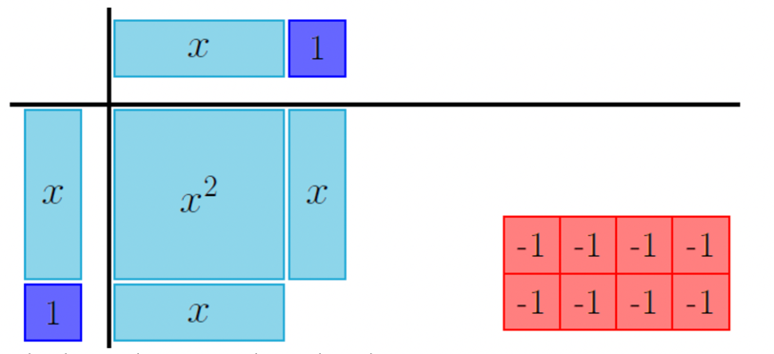
Write the equivalent expression by completing the square.
$${(x+1)}^{2}-9$$

